PRACTICAL 8
MySQL Schema Design, ER Model, PDO Connectivity, and Prepared Statements
StudentHub Database
Student Name | Mann S Patel________________________________
Enrollment Number | D26CS126________________________________
Class / Division | CSE(Division:2)________________________________
Date of Submission | ________________________________

1. Aim
To design a normalized MySQL database for StudentHub with students, events, and registrations tables, and to connect PHP to MySQL securely using PDO and prepared statements.

2. Objectives
- Design related tables with suitable data types and constraints.
- Apply primary keys, foreign keys, and a unique constraint to preserve data integrity.
- Insert sample data for students, events, and registrations.
- Create a reusable PDO connection file with exception-based error handling.
- Retrieve database records using prepared statements and display the output in a browser.

3. Software Requirements
Software / Tool | Purpose
XAMPP | Runs Apache, PHP, and MySQL locally
MySQL / phpMyAdmin | Creates and manages the database
PHP with PDO extension | Connects to MySQL and executes prepared queries
Visual Studio Code | Edits SQL and PHP files
Web browser | Displays and tests the application

4. Theory

4.1 Database Schema and Normalization
A database schema defines tables, columns, data types, and relationships. Normalization organizes data to reduce duplication and avoid insertion, update, and deletion anomalies. In this design, student details are stored in students, event details in events, and the relationship between them in registrations. Each table stores facts about one entity or relationship, supporting a practical third-normal-form design.

4.2 Entity Relationships
A student may register for multiple events, and an event may have multiple students. This many-to-many relationship is represented by the registrations junction table.
- students.student_id → registrations.student_id (one-to-many)
- events.event_id → registrations.event_id (one-to-many)
- UNIQUE(student_id, event_id) prevents the same student from registering for the same event twice.

4.3 Primary and Foreign Keys
A primary key uniquely identifies a row. A foreign key references a key in another table and helps maintain referential integrity. The registrations table contains foreign keys to both students and events. ON DELETE CASCADE removes related registrations if a referenced student or event is deleted.

4.4 PDO and Prepared Statements
PDO (PHP Data Objects) provides a consistent interface for database access. Prepared statements separate SQL structure from supplied values. This reduces SQL injection risk when values are bound correctly. The connection uses exception mode so database errors can be handled through try-catch.

4.5 Error Handling
The connection code catches PDOException, writes technical details to the PHP error log, and shows a generic message to the browser instead of exposing database credentials or internal error details.

5. Database Design
Table | Primary key | Important columns | Relationship
students | student_id | full_name, email (unique), department, created_at | One student can have many registrations
events | event_id | title, event_date, location, category, created_at | One event can have many registrations
registrations | registration_id | student_id, event_id, registration_date | Links students and events; unique student/event pair

6. Implementation Files
The accompanying StudentHub_Practical8 folder contains schema.sql, db.php, test_connection.php, and README.txt. The complete source files are provided separately in the project ZIP. The following excerpts show the key implementation points.

6.1 schema.sql
CREATE TABLE students (
student_id INT UNSIGNED AUTO_INCREMENT PRIMARY KEY,
full_name VARCHAR(100) NOT NULL,
email VARCHAR(150) NOT NULL UNIQUE,
department VARCHAR(100) NOT NULL,
created_at TIMESTAMP NOT NULL DEFAULT CURRENT_TIMESTAMP
) ENGINE=InnoDB;
CREATE TABLE events (
event_id INT UNSIGNED AUTO_INCREMENT PRIMARY KEY,
title VARCHAR(150) NOT NULL,
event_date DATE NOT NULL,
location VARCHAR(150) NOT NULL,
category VARCHAR(50) NOT NULL,
created_at TIMESTAMP NOT NULL DEFAULT CURRENT_TIMESTAMP
) ENGINE=InnoDB;
CREATE TABLE registrations (
registration_id INT UNSIGNED AUTO_INCREMENT PRIMARY KEY,
student_id INT UNSIGNED NOT NULL,
event_id INT UNSIGNED NOT NULL,
registration_date TIMESTAMP NOT NULL DEFAULT CURRENT_TIMESTAMP,
FOREIGN KEY (student_id) REFERENCES students(student_id)
ON UPDATE CASCADE ON DELETE CASCADE,
FOREIGN KEY (event_id) REFERENCES events(event_id)
ON UPDATE CASCADE ON DELETE CASCADE,
UNIQUE (student_id, event_id)
) ENGINE=InnoDB;

6.2 db.php
$dsn = "mysql:host=localhost;dbname=studenthub_db;charset=utf8mb4";
try {
$pdo = new PDO($dsn, 'root', '', [
PDO::ATTR_ERRMODE => PDO::ERRMODE_EXCEPTION,
PDO::ATTR_DEFAULT_FETCH_MODE => PDO::FETCH_ASSOC,
PDO::ATTR_EMULATE_PREPARES => false,
]);
} catch (PDOException $e) {
error_log('StudentHub database connection failed: ' . $e->getMessage());
http_response_code(500);
exit('Database connection failed. Check XAMPP/MySQL and db.php settings.');
}
Note: The provided file includes the complete PHP opening tag, strict typing declaration, and connection settings. The default root/empty-password credentials are for a typical local XAMPP setup only.

6.3 test_connection.php — Prepared Statement
$stmt = $pdo->prepare(
"SELECT event_id, title, event_date, location, category
FROM events WHERE category = :category ORDER BY event_date ASC"
);
$stmt->bindValue(':category', $category, PDO::PARAM_STR);
$stmt->execute();
$events = $stmt->fetchAll();
The full test_connection.php page displays students, events, and registrations. It also includes a category filter whose value is passed through a prepared statement.

7. Procedure
- Extract the StudentHub_Practical8 ZIP folder.
- Copy the StudentHub folder to C:\xampp\htdocs\StudentHub\.
- Open XAMPP Control Panel and start Apache and MySQL.
- Open http://localhost/phpmyadmin/ in a browser.
- Use the Import tab to import schema.sql and create the studenthub_db database and its three tables.
- Confirm that students, events, and registrations appear in the database.
- Open http://localhost/StudentHub/test_connection.php.
- Verify the successful PDO connection message and the displayed student, event, and registration records.
- Test the category filter and Reset link to confirm the prepared query works.

8. Output Screenshots
Insert screenshots captured from your own XAMPP/phpMyAdmin/browser session in the spaces below. Do not submit these placeholders as if they were actual output.

Screenshot 1 — Database tables in phpMyAdmin
Show studenthub_db with students, events, and registrations visible.

The phpMyAdmin Structure view confirms that studenthub_db contains the students, events, and registrations tables. The screenshot shows 3 student rows, 3 event rows, and 4 registration rows.

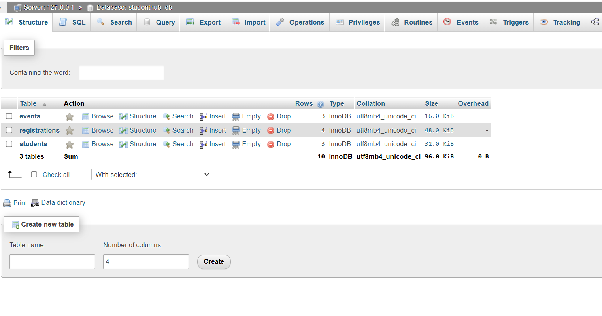

Screenshot 2 — Foreign key structure
Show the registrations table structure and its student_id and event_id foreign-key relationships.
The registrations table structure shows registration_id as the primary key, student_id and event_id as indexed relationship columns, and a unique composite index (uq_student_event) on student_id and event_id to prevent duplicate registrations for the same student and event.

Note: This screenshot documents the table structure and indexes. If the evaluator specifically requires proof of the referenced foreign-key tables, click Relation View in phpMyAdmin and capture the section showing student_id → students.student_id and event_id → events.event_id.

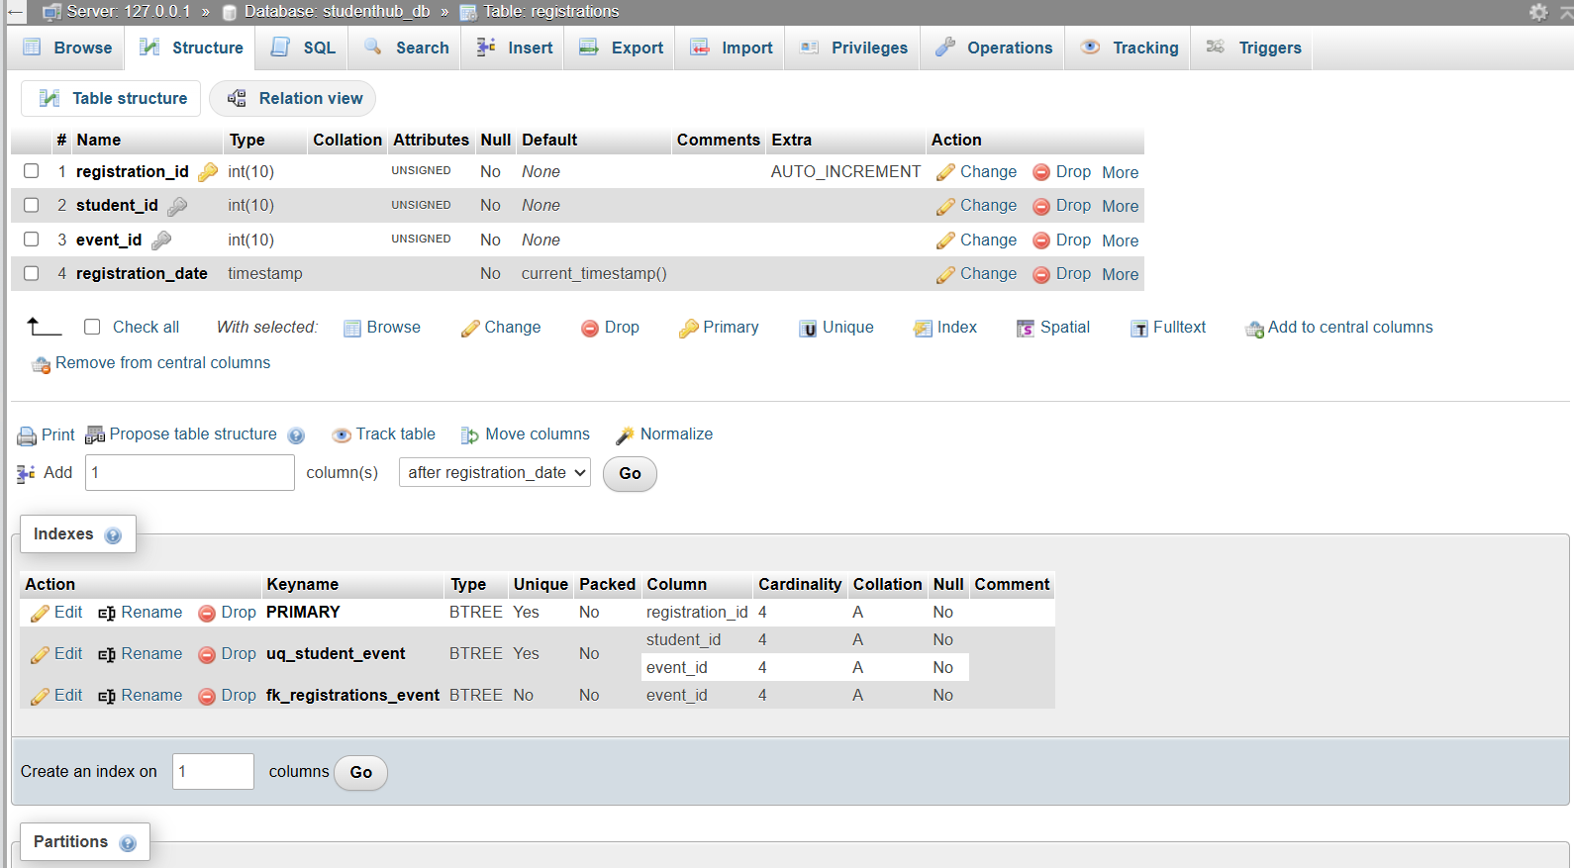
The Relation View confirms both foreign-key constraints in the registrations table: event_id references events.event_id, and student_id references students.student_id. Both constraints use ON DELETE CASCADE and ON UPDATE CASCADE.

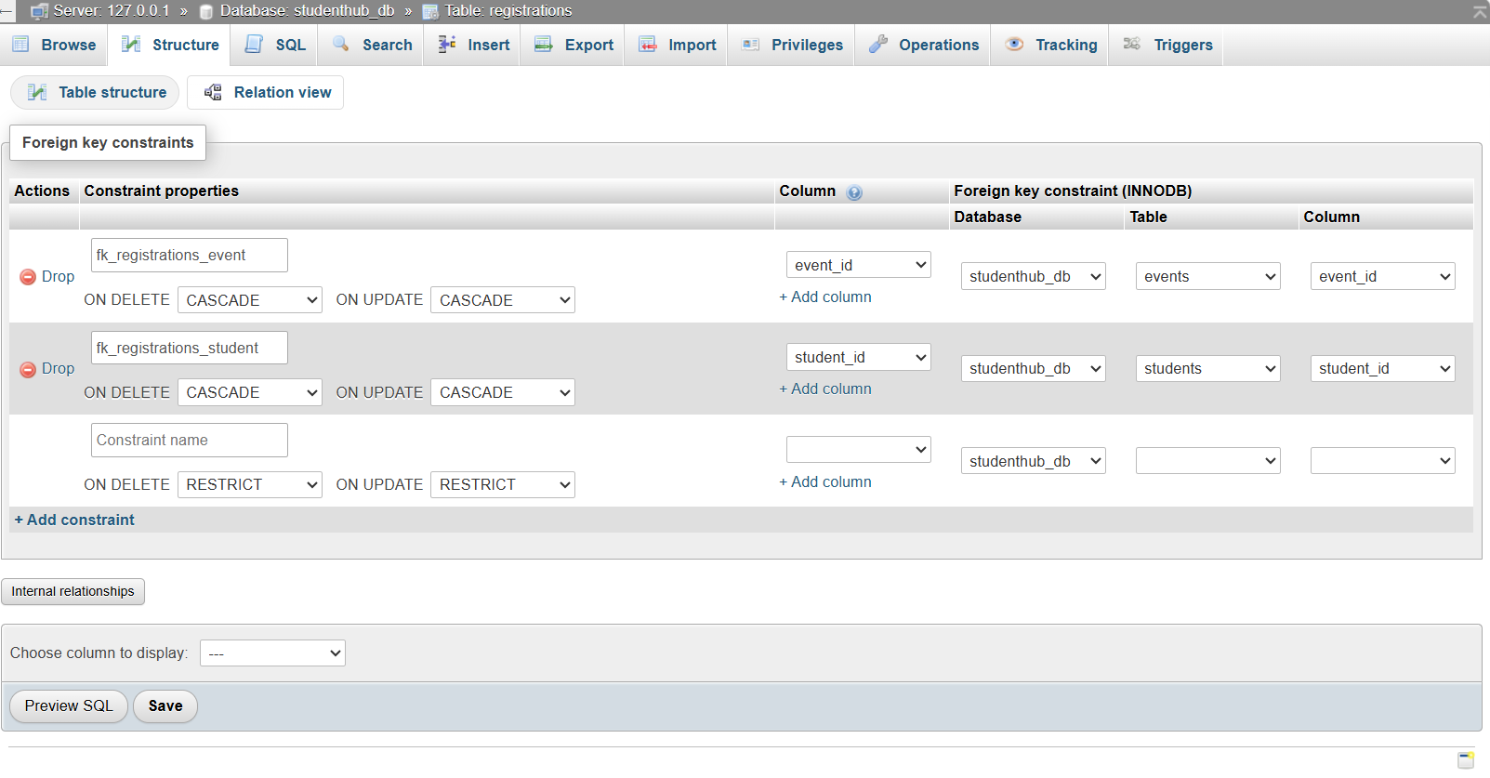

Screenshot 3 — Browser output
Show test_connection.php with the successful connection message and the displayed tables.
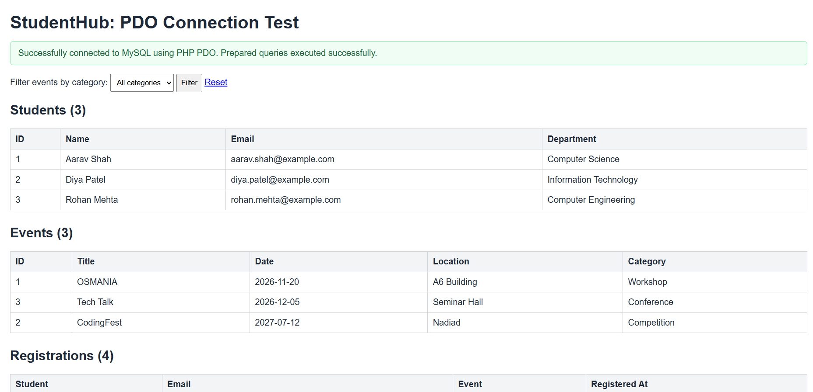
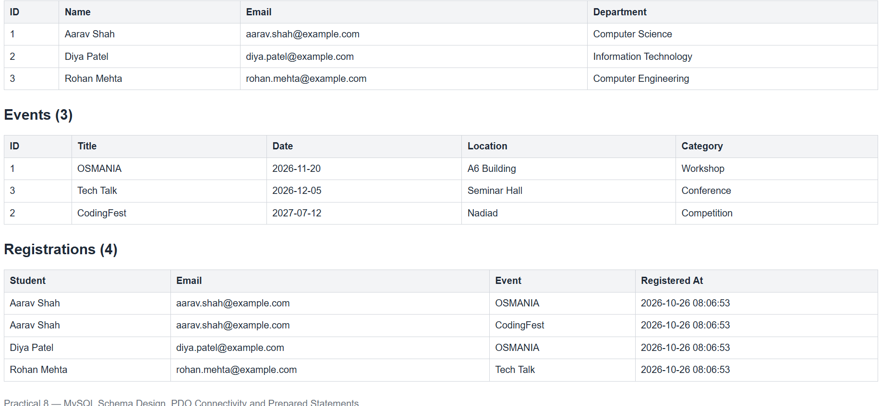

9. Result
The StudentHub database schema and PHP PDO test application have been prepared. After importing schema.sql and running the project in XAMPP, the application should connect to MySQL, execute prepared queries, and display students, events, and registrations. Confirm successful execution on the local system and insert the required screenshots before submission.

10. Conclusion
This practical demonstrates relational database design, normalization principles, primary and foreign keys, PDO-based PHP connectivity, exception handling, and prepared statements. The registrations junction table implements the many-to-many relationship between students and events.

